P&C Meeting Minutes
2 Aug 2023
7:00pm, School Library and Zoom
Attendance | Name | Class
Online | Troy Steel | 4H
 | Kylie Tanner | 3D
 | Liz Russell | 3/4B
 | Karen Vajda-Shabty | 5/6A, 3D
 | James Maher
In Person
 | Kate Owen | Assistant Principal
 | Marina Alexiou | Assistant Principal
 | Daniel Baker | Assistant Principal
 | Simon Pillidge | Exec
 | Jodie Steele | 4H
 | Helen Randall | 5/6 H, 2E
 | Simon Griffin
 | Jenny Monaghan | Exec
 | Jen Forde | 4H
 | Rebecka Blacker | 2L, 3/4B 5/6P
 | Rachel Knight | 2L / 4H
 | Leanne Economou | 2E
Apologies – Jenny Connell, Jacqui Busby, Mel Bramich, Jamie Bohm, Trish Fisher
- Welcome:
Simon (Secretary) gave the acknowledgment of Country

- Minutes of Previous Meeting:

  - Proposed: Jodie Steele
  - Seconded: Rachel Knight

- Reports

  - Principal’s report – delivered by Kate Owen in the absence of Trish Fisher, she thanked the P&C for their work and provided a brief update on upcoming events.
  - President’s report – delivered by Helen Randall. See Appendix A
  - Treasurer’s report – delivered by Jen Forde See Appendix B

- General Updates
- Uniform Shop update from Jodie Steele
  - Changing the Kindy packs to make them more affordable and will include a 10% off voucher for first uniform purchase
  - Will need to increase some prices as they haven’t been increased for a few years. First will be hats going from $20 to $22
- OSSH Update provided by Jack and given by Helen
  - Vacation care went very well including outings and visit from Coogee OOSH
  - Enrolment period will be term 4 and info coming out in term 3
  - 15 September – free OOSH BBQ
  - After success of term 2 movie night considering redoing this at end of year
  - New sign in and out app so make sure you download it
  - Have restarted learning centre excursions for the older kids

- Other Business
- Daniel Baker gave an update that the school has applied for funding for a wellbeing officer and noted that the role will be non-religious even though previously known as a Chaplin. If the school gets funding it will likely be 2 days per week.

Meeting Closed at 7:35pm

Appendix A – President’s Report
Good evening everybody, and welcome to a very busy Term 3 for the P&C team. We have a lot of events this term, so we hope that people will want to get involved whether volunteering some time or attending.

Firstly, I wanted to say what a fantastic job the team did of organising our Winter Snow Ball Disco last term. I am sure anyone that went will agree the hall looked amazing and the snow machine was a big hit! So a big thanks to everyone involved, the Exec team plus Liz for the organisation, Jacey from Baby Bash Balloons for donating the balloon art. And last but by no means least, to everyone that helped out on the night – ticket sales, the BBQ, selling glow sticks, cake stalls, bakers, decorating, clean up crew. So many people really got involved and we are so grateful, it really does take a village to pull off these events. I am sure the kids had a blast, any feedback on the split disco times would be great. We are still crunching the final numbers, as our Treasurer has absconded to Europe, but we definitely made in excess of $4000 which will be donated to the school for literacy resources for years 3-6.

Thanks also to Mel Bramich and the Kindy parent reps for helping with the hall decorations for the 100 days of Kindy celebrations. Special thanks to Mel for baking 60 cupcakes for everyone to enjoy!

Now on to this term! You may have already received a leaflet and seen the information online regarding our Picture Products fundraiser. The kids are all in their classes busily creating some beautiful artwork that we will be printing on to melamine plates that last for years to come. If you wish to order one you can do so online, the plates will be ready for collection prior to Christmas if you want copies for presents. You can also get extra templates, so if you want to make more plates for siblings or baby handprints etc that is possible, just submit the artwork back to school by the 18 August. There are also extra products you can create if you wish – from water bottles, calendars, tote bags, mugs and much more. Please note however, that these products all require different templates so if you want something else you will need to create the artwork at home. You can pick up a template from the office for alternative products, or download using the links provided. So you have the option to have it all done for you, and order a plate… or get artsy at home and choose something else.

Our other major fundraiser this term is the 80s Trivia Night which will be on the 8 September at Maroubra Juniors. This is going to be such a fun night, so pull out your leg warmers, crimpers and hyper colour t shirts! This is our first adult only event in many years, so leave the kids at home for this one. We will have the trivia itself hosted by Hayley Kirk, then an 80s mix tape playing in to the night for a boogie. Alongside the trivia we have some amazing prizes to be won, a chocolate wheel and a silent auction. Donations have been flooding in and there are some great things to bid on – from kids vacation camps, tutoring packages, golf, hair, make up, massage, fitness memberships, restaurant vouchers, family activities… so many options and something for everyone. If anyone in our community has anything they would like to donate please reach out to myself or Jacqui. Tickets are on sale now, and so get in quick! We are selling both individual tickets, or if you have a crew you want to go with you can also buy tables of 10 at a slightly discounted price.

Proceeds from these fundraisers will be going towards the new outdoor learning area in the paddock that Trish discussed in the last P&C. The plans look amazing, so I am sure the kids will be keen to get them from paper to reality.

And just in case that wasn’t enough for one term, we also have the book parade and fathers day breakfast – you will all be pleased to hear a coffee cart has been secured for both. The P&C will be asking for help with a cake stall, and the traditional fathers day BBQ breakfast so please consider donating an hour or two if you can. The book fair is also running that week, with book sales gaining points for the school to spend on new library books. Again please support that if you are able, either by purchasing a book or donating an hour to help out.

Finally, Musicale is also on this term! The band, choir and dance parents will be asked to help out with funds from that event going back to the music programme at the school.

So in summary, loads to get involved with this term! We hope to see you all at something, there is plenty to choose from.

Appendix B – Treasurer’s Report
Treasurer’s Report 2 August 2023 (Term 3, week 3)

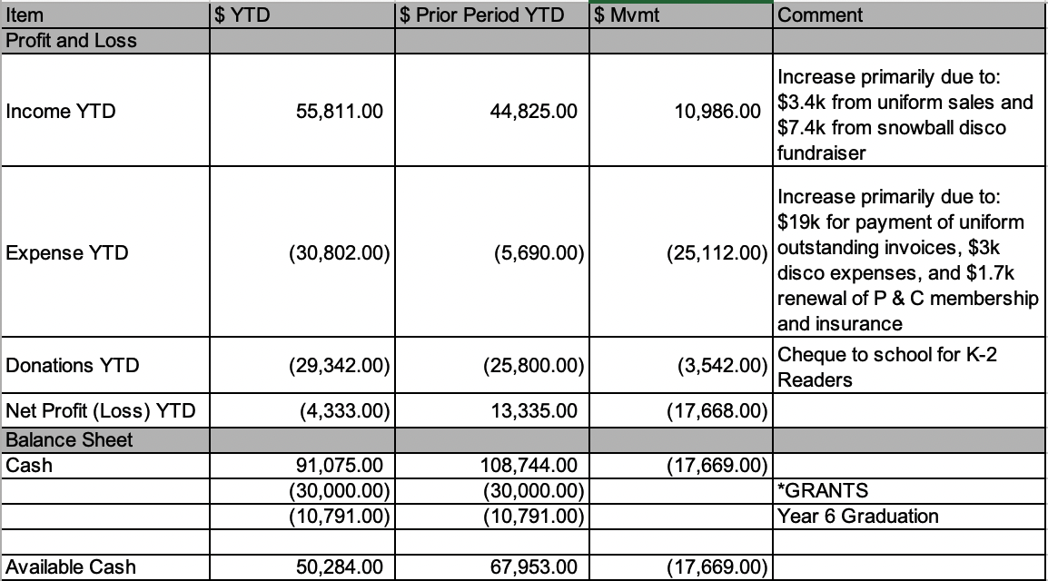

* Outdoor kitchen $27k and sensory path $3k.

Events (excluding Yr 6 graduation fundraising)
Events | Funds Raised | Purpose
Bunnings BBQ $634  Easter Stall/Raffle $1,768  Parent Contributions $1,140 | $3,542 | K-2 Readers
Mother’s Day Breakfast | $1,219
Snowball Disco | $4,432

Available cash going forward is $50k.
The P&C Executive are working on formalising a reserves policy regarding the appropriate level of cash reserves and will look to table the policy in term 3.

Profit and Loss South Coogee Parents & Citizens Association
For the 7 months ended 31 July 2023
 | 2023
Trading Income
Uniform Sales | 29,479.70
Total Trading Income | 29,479.70
Cost of Sales
Uniform Costs | 19,030.55
Total Cost of Sales | 19,030.55
Gross Profit | 10,449.15
Other Income
Interest Income | 467.97
P & C Membership | 28.00
Parent Contributions K-2 Readers | 1,140.00
Total Other Income | 1,635.97
Fundraising Events
Event Income & Sales | 100.15
Easter Raffle and Treats | 1,801.00
Bunnings BBQ | 675.68
Mother's Day Breakfast | 2,199.34
Snowball Disco | 7,438.02
Year 6 Graduation Fundraisers | 12,481.20
Total Fundraising Events | 24,695.39
Fundraising Expenses
Event Expenses | 604.61
Mother's Day Breakfast Expenses | 979.85
Year 6 Fundraising Expenses | 640.20
Twilight Cinema Expenses | 1,679.50
Easter Treats | 33.20
Disco Expenses | 3,005.22
Trivia Expenses | 650.00
Total Fundraising Expenses | 7,592.58
Other Expenses
Bank Fees | 330.95
General Expenses | 426.94
Insurance | 1,686.00
Telephone & Internet | 130.00
Xero subscription | 203.00
Year 6 Graduation | 1,050.00
Meeting Expenses | 352.95
Total Other Expenses | 4,179.84
Payments to School
Teachers Tea & Coffee | 2,000.00
Numeracy and Literacy Resources | 20,000.00
Teacher Classroom Resources | 3,800.00
K-2 Readers | 3,542.00
Total Payments to School | 29,342.00
Net Profit | (4,333.91)

Balance Sheet
As at 31 July 2023
Account | 31 Jul 2023
Assets
Bank
Bendigo Bank | 84,540.58
CBA Cheque Account | 6,535.39
Total Bank | 91,075.97
Current Assets
Accounts Receivable | 1,500.00
Inventory on Hand | 57,474.15
Total Current Assets | 58,974.15
Total Assets | 150,050.12
Net Assets | 150,050.12
Equity
Current Year Earnings | (4,333.91)
Surplus / Deficit | 154,384.03
Total Equity | 150,050.12

